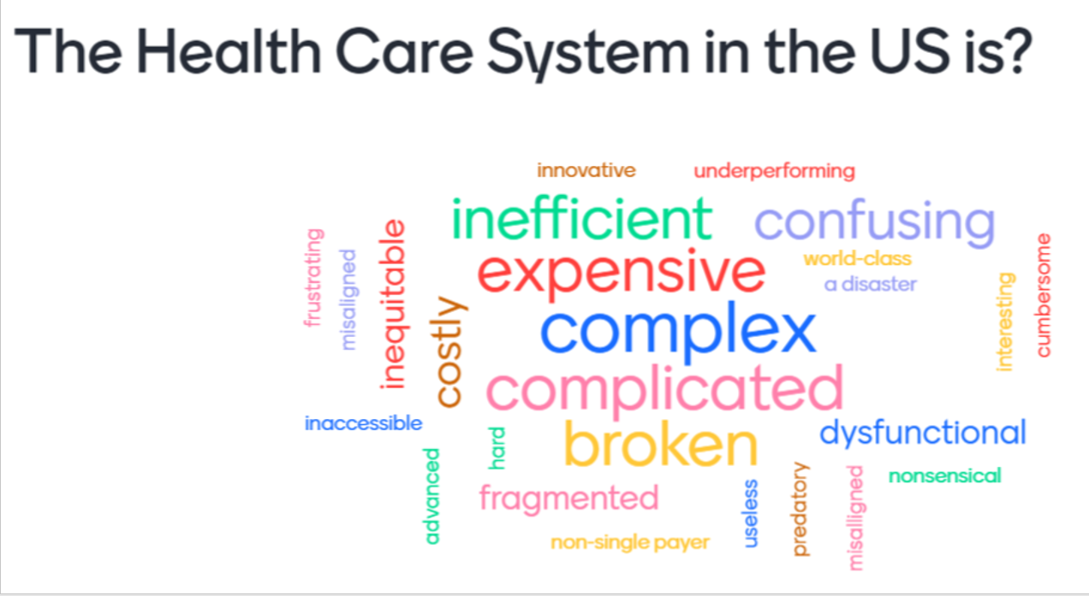

Healthcare has a major role in all economies. This course is designed to give a broad overview of the US health care system from a business and policy perspective. With health care approaching 20% of the US GDP consulting, banking, finance, investing, and venture capital are all involved in this sector. No matter what field you are going into you need to have a fundamental understanding of the idiosyncrasies of health care.

No previous experience in health care is required for this course. The elective will examine the structure and component parts of the health care system and will study basic economic issues, public policies, and market developments as they impact the industry and the delivery of care and services.

Academic Objectives of the Course
- Provide an overview of the nature of health systems and the challenges they face.
- Outline the key business structures in the current health care system.
- Understand the challenges faced by Pharma and the Biotech industry.
- Understand the challenges faced by health care providers.
- Address the approach to safety and qaulity in the delivery of care.

Each class will start with a case (and usually multiple in class votes). I also have guests in each class to provide expertise on the different aspects of the health value chain.

Past guests

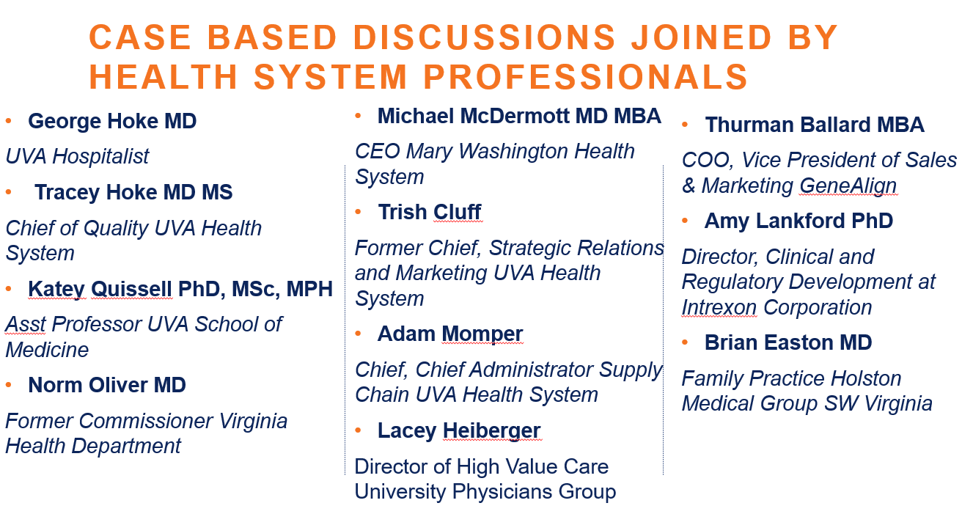
In Class participation 30%
I grade on a 3 point scale. 1 point for attending class, 1 point for contribution and another point if you contribute in a significant way.

Discussion questions write up. 15%
During the course you will be assigned 1 set of discussion questions from the case for the day to write-up (1-2 pages). The questions are outlined in the daily calendar and will be assigned in canvas. They are due by 7 pm the day before class.
Group Project(s) 30%
The group projects will be will be conducted with 4-7 students in each group. Groups will be randomly assigned after add drop is over. There are two parts for this assignment:

- Leading a discussion with the Guests (10%) For guests we will devote 25 minutes for Q&A. Each group will prepare some questions and then lead the discussion. This assignment will coincide with the day your discussion questions are assigned. Questions need to be posted in Canvas by
7 pm the day before class so that I can send them to the speaker.
- Choose drugs to advance for development for the Vertex case (20%). Read the case and meet with your group to choose the candidates to develop or hold or sell. In class we will discuss the case and then each group will present their choices (2 or 3 slides). The slides are due by 7pm the day before class.

Final Paper 25%
The final paper is a 2-3 page single spaced essay outlining what you found the most surprising or enlightening or frightening about the health care sector during this course. It can be specific or more general. I want you to reflect on how this new learning will shape your engagement with the Health Sector during your professional career or your personal life.

